**STEP BY STEP SNAPSHOTS OF LOCKME APPLICATION**

Welcome Page

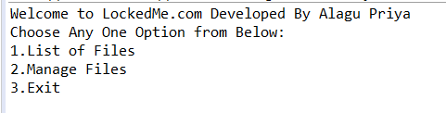

Select 1 when no files are added

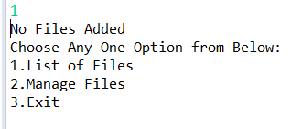

Select 2

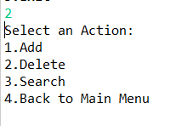

Select 1 in the Actions Menu

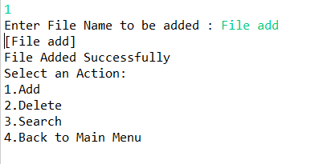

Select 2 in Actions Menu

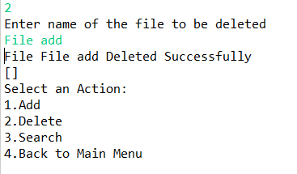

Add 2 files (add, sub)

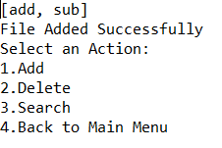

Select 3 to search a file

(Results display when correct file name is entered)

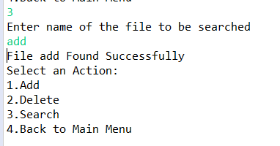

Select 3 and enter incorrect file name

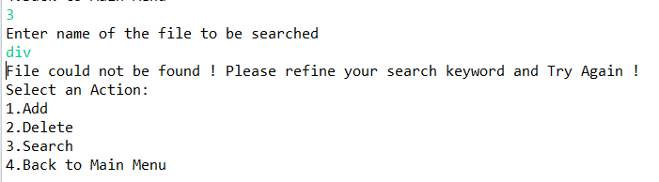

Select 4 to go back to main menu

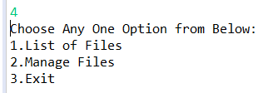

Select 1 in the main menu

(Prints list of files in ascending order)

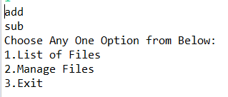

Select 3 to Exit

